What will we be learning?  Unit FO92 – Person-centred approach to care | Why this? Why now?  This unit is completed in Year 12 in the Autumn. It is a compulsory unit. It runs alongside F090 the examined unit delivered during Year 12. | Key Words/terms:  Person-centred approach  Values  Co-production  Service user  Practitioner  Personalisation  Independence  Inclusion  Planning tools  One-page profile  Impairment  Cognitive  Statutory  SOLER theory
What will we learn?
- TA1 – Taking a person-centred approach
- TA2 – Meeting needs and providing support in a person-centred way
- TA3 – Communication skills needed to offer person-centred care

What opportunities are there for wider study?
Careers/degree courses
- Social care
- Childcare
- Health care

Further reading:
Describe different working relationships in care settings – DSDWEB: FREE STUDY GUIDES FOR CARE QUALIFICATIONS
Timeline of Baby P case - BBC News
Inquiry investigates deaths of 1,500 NHS mental health patients in Essex | Mental health | The Guardian
How will I be assessed?
- OCR set assignments on Teams.
AAQ – HEALTH & SOCIAL CARE
UNIT F092

TA1 – TAKING A PERSON-CENTRED APPROACH  - Current context of the person-centred approach  - What a person-centred approach is  - Independence and rights  - Benefits of a person-centred approach  - Methods used to ensure a person-centred approach | 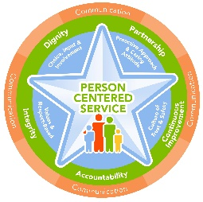
TA2 – MEETING NEEDS AND PROVIDING SUPPORT IN A PERSON-CENTRED WAY  2.1 Types of impairment  2.2 Impact of an impairment on an individual’s daily life  2.3 Understanding care and support needs arising from impairment  2.4 Addressing care and support needs | 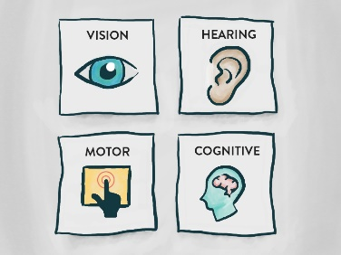
TA3 – COMMUNICATION SKILLS NEEDED TO OFFER PERSON-CENTRED CARE  - Verbal communications skills  - Non-verbal communication skills  - Factors which enhance/inhibit communication  - Written communications skills in health and social care | 

